## **ecrNow Project Setup Instructions**

### **Step 1: Create the Folder Structure**

1. Open your terminal or file explorer.
2. Navigate to the directory where you want to create the ecr-now project.
3. Create the main project folder named ecr-now.
4. Inside the ecr-now folder, create the following subdirectories:
   * schematron
   * schemas
   * kars
     + electronic-case-reporting
   * bsa-output
   * custom-queries

**ECR-NOW FOLDER STRUCTURE**

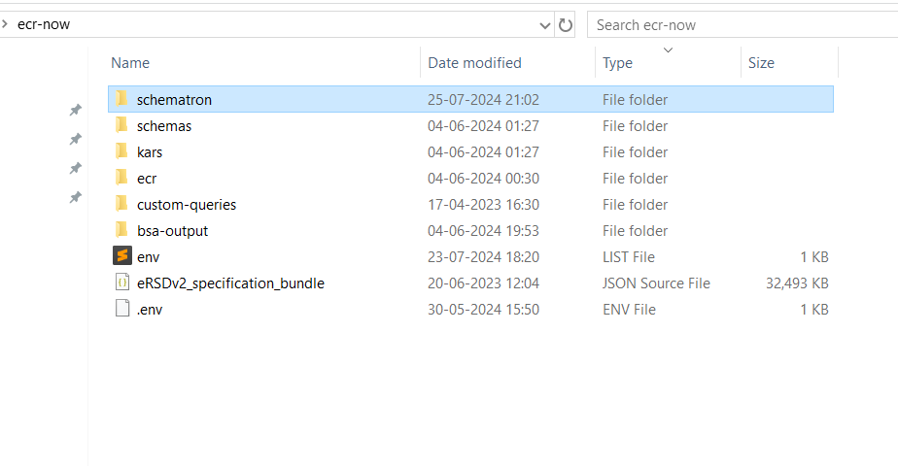

**The folder structure should look like this:**

* + ecr-now/
  + ├── ecrNow.log
  + ├── eRSDv2_specification_bundle.json
  + ├── schematron/
  + │ └── CDAR2_IG_PHCASERPT_R2_STU1.1_SCHEMATRON.sch
  + ├── schemas/
  + │ └── CDA_SDTC.xsd
  + ├── kars/
  + │ ├── electronic-case-reporting/
  + │ └── eRSDv2_specification_bundle.json
  + ├── bsa-output/
  + ├── custom-queries/

### 

### 

### 

### 

### 

### **Step 2: Place the Files in the Appropriate Folders**

1. **ecrNow.log**
   * **Location:** ecr-now/
   * **Description:** Log file for the application.
   * **How to Obtain:** This file will be created by the application at runtime.

1. **eRSDv2_specification_bundle.json**
   * **Location:** ecr-now/
   * **Description:** The eRSD v2 specification bundle in JSON format.
   * **How to Obtain:**   
     ERSD file can be downloaded by registering for an account at : [https://ersd.aimsplatform.org](https://ersd.aimsplatform.org/) Currently this link only works state-side and if you are out of country, please contact us to figure out how we can get you a copy of it through the right means.
   * For Release 2.X of the application, the ERSD v1 Specification Bundle should be used.
   * For Release 3.X of the application using the systemLaunch API, the ERSD v1 Specification Bundle should be used.
   * For Release 3.X of the application using the launchPatient API, the ERSD v2 Specification Bundle should be used.
2. **SCHEMATRON DIRECTORY  
   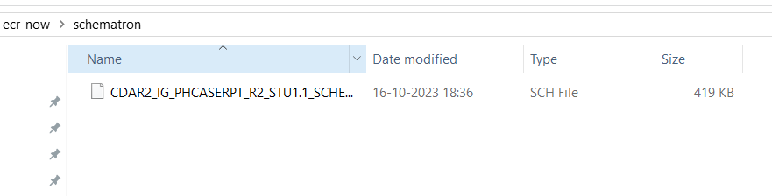**
   * **Location:** ecr-now/schematron/
   * **Description: CDAR2_IG_PHCASERPT_R2_STU1.1_SCHEMATRON.sch** Schematron file for validating CDA R2 PHCase reports.
   * **How to Obtain:** Download from the official HL7 website or the project repository.
3. **Schemas DIRECTORY**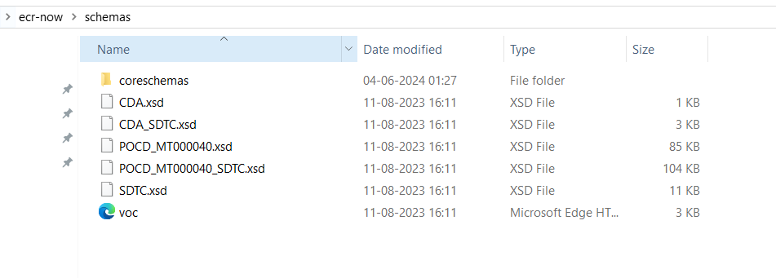
   * **Location:** ecr-now/schemas/
   * **Description:** XML Schema Definition (XSD) file for CDA SDTC.
   * **How to Obtain:** Download from the official HL7 website or the project repository.
4. **KARS DIRECTORY(Knowledge Artifact Repository)**

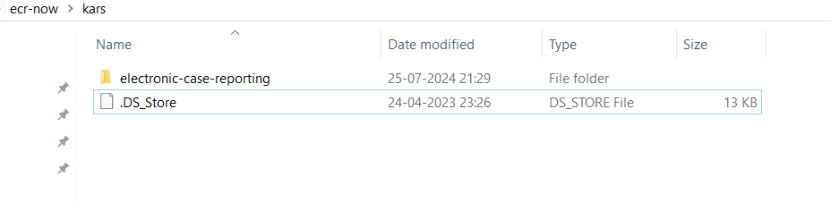

**5.1 Electronic-case-reporting** **DIRECTORY  
  
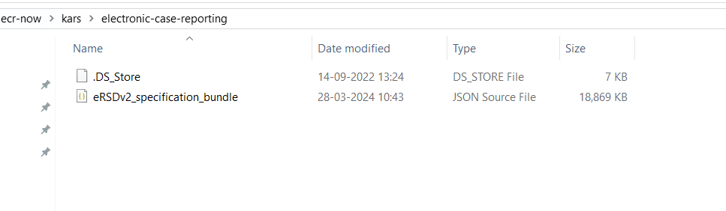**

* + **Location:** ecr-now/kars/electronic-case-reporting/
  + **Description:** Directory to store KAR files for electronic case reporting.
  + **Files to Include:** eRSDv2_specification_bundle.json
  + **How to Obtain:** Files will be downloaded by the ESRD Website(<https://ersd.aimsplatform.org/#/home>)

1. **Bsa-output**  **DIRECTORY**

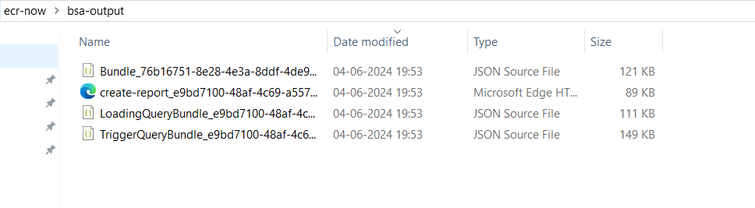

* + **Location:** ecr-now/bsa-output/
  + **Description:** Directory to store BSA (Business Service Automation) output files.
  + **How to Obtain :** The application will generate the creat-report.xml, LoadingQueryBundle.json, and TriggerQueryBundle.json files upon making the Launch Patient API call.

1. **Custom-queries DIRECTORY  
     
   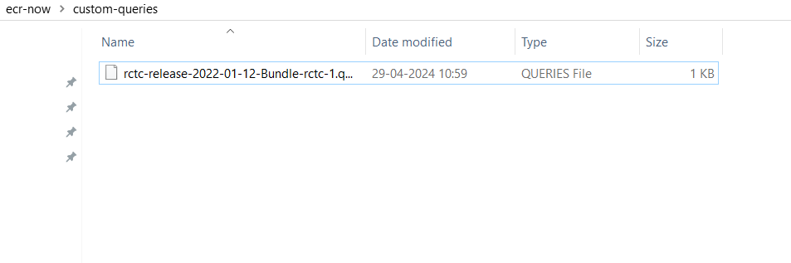**
   * **Location:** ecr-now/custom-queries/
   * **Description:** Directory to store custom query files.
   * **How to Obtain:** we will be create custom Queries File